**Assignment No -2**

**Name** -Sakshi Raju Yadav

**Date** – 11/04/2024

1.Create the following table with the given data as follows.

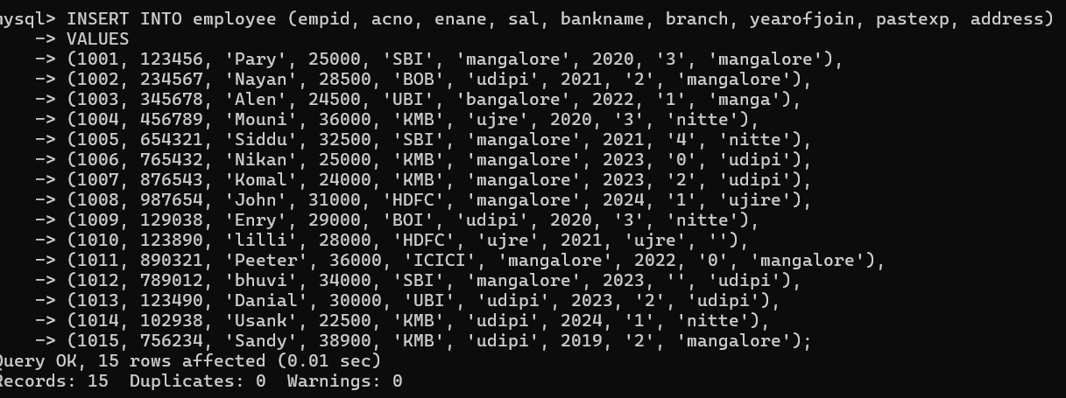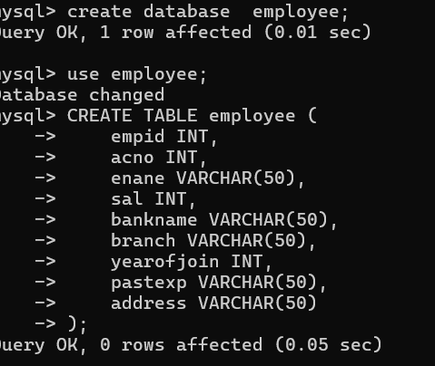

2. Write a query to display all the records from the table.

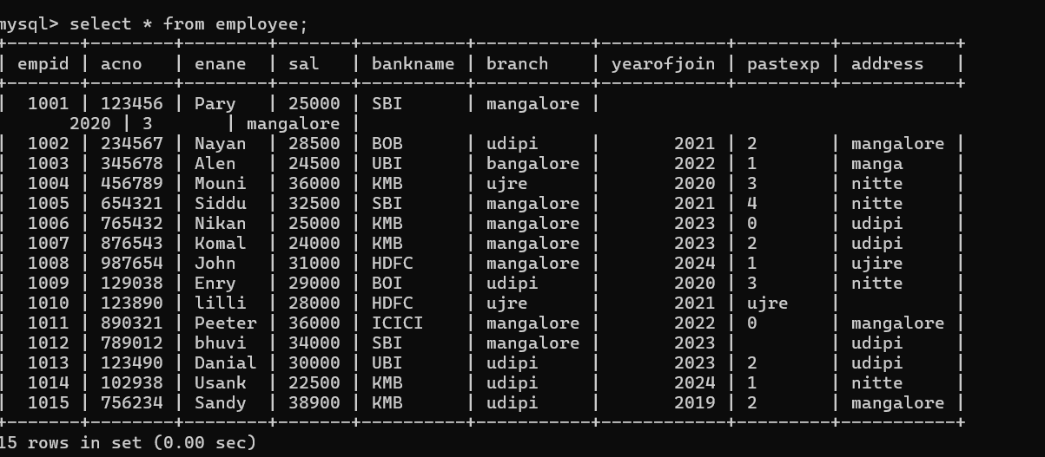

3.Write a query to display all the records from the table, whose branch and address both are the same.

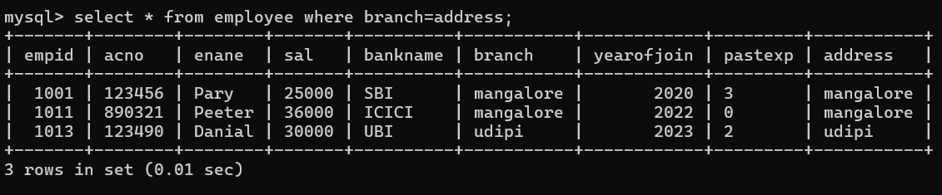

4. Write a query to display employee acno, ename, bankname, and branch details whose salary is more than 30000.

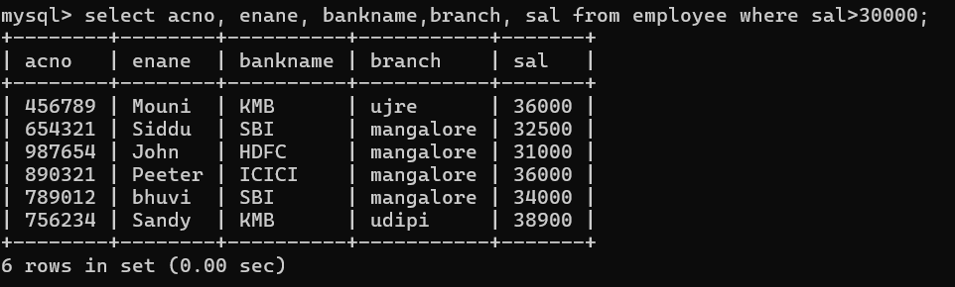

5. Write a query to display employee records who are earning less than 25000

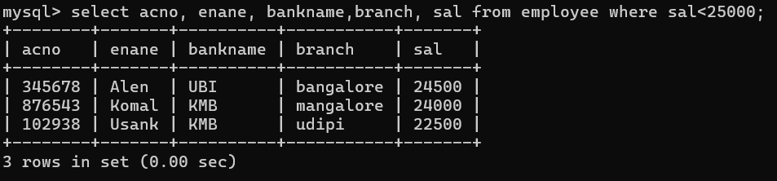

6. Write a query to display the employee record of who is earning the highest salary.

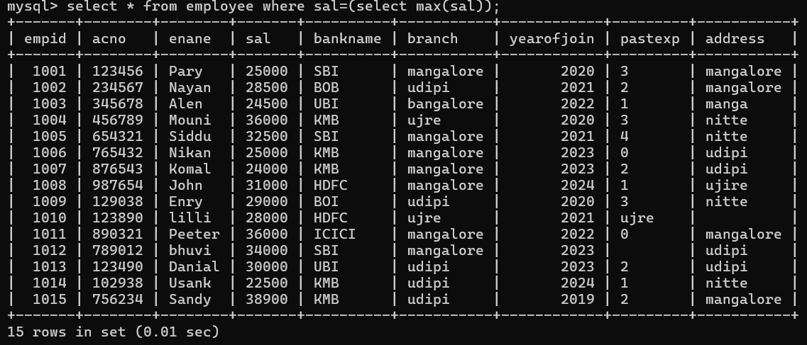

7. Write a query to display the employee name who is earning less salary.

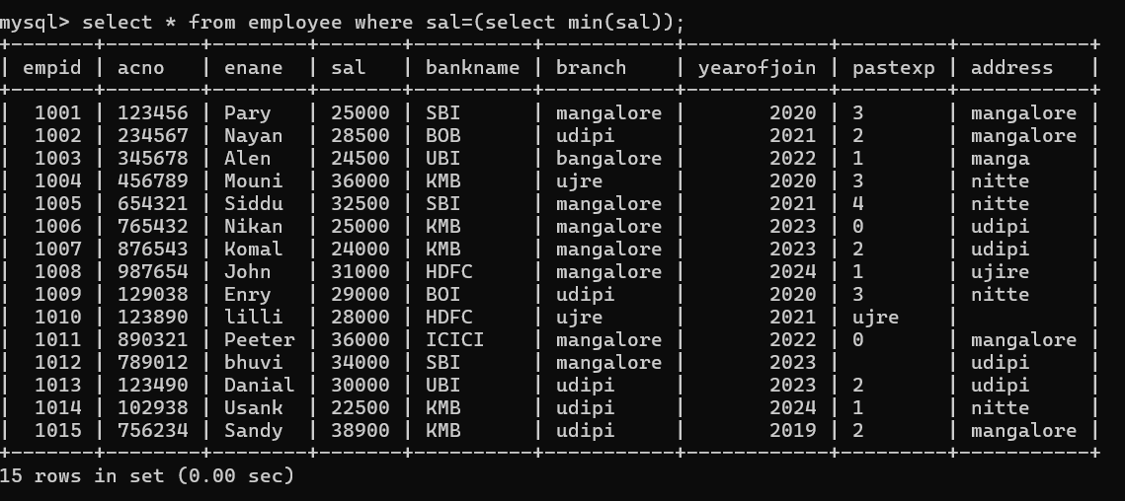

8. Write a query to the employee ename, acno, and bankname who are earning in between 25000 and 32000 (both are included).

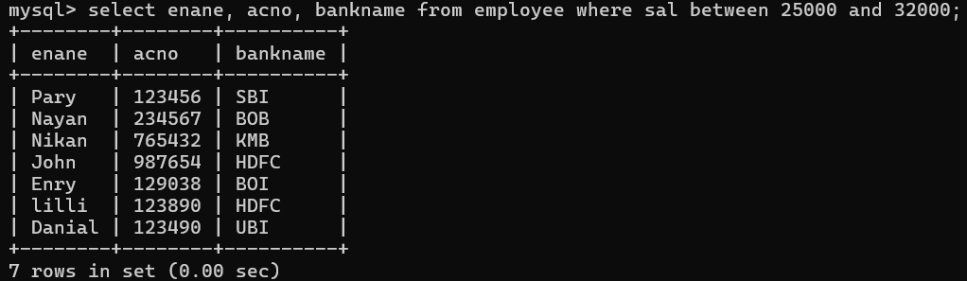

9. Write a query to display eid, ename, sal, acno who have an account in SBI bank.

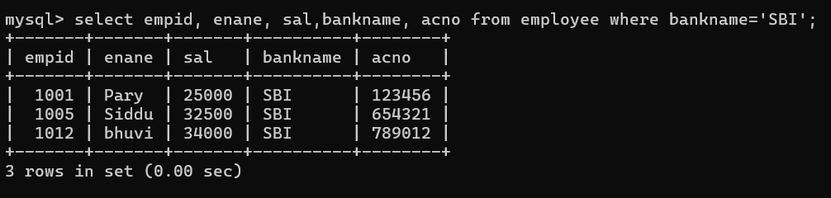

10. Write a query to display eid, ename, sal, acno who have an account in ICICI bank and from udipi branch.

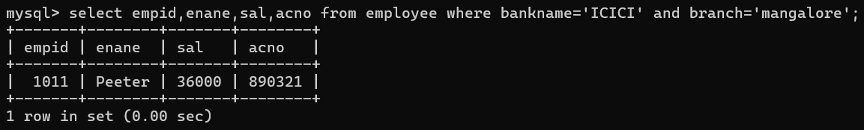

11. Write a query to display eid, ename, sal, acno who have joined before 2023(2023 is excluded).

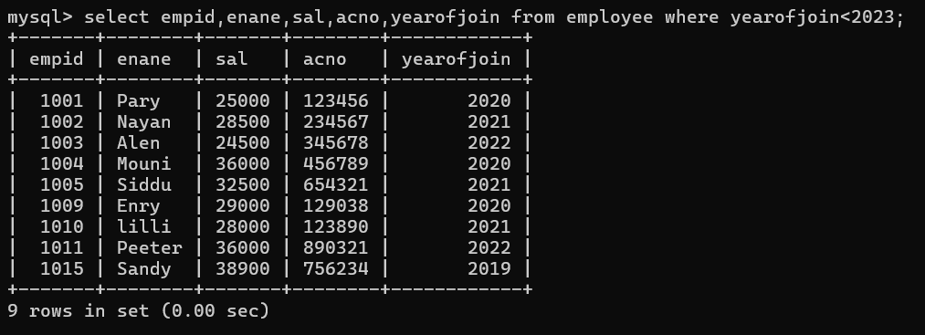

12. Write a query to display eid, ename, sal, acno, bankname and branch who have an account in SBI bank and joined after 2022.

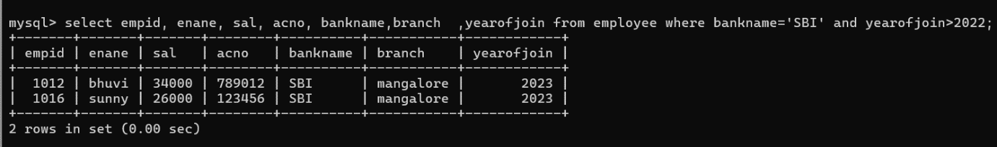

13. Write a query to display eid, ename, sal, acno, address who have joined early from mangalore.

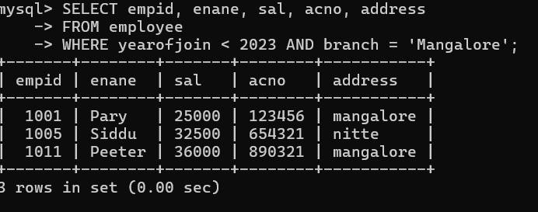

14. Write a query to display eid, ename, sal, acno who have an account in SBI bank and whose name starts with 'p'.

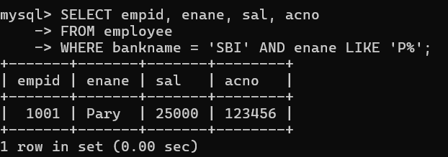

The **LIKE** operator in SQL is used to search for a specified pattern in a column.

15. Write a query to display the number of employees having the same salary and that salary from the table.